**KEEP** **TRACK** **OF** **INVENTORY**

**• Project title:** Store manage – keep track of inventory

**•Team Id**: NM2025TMID29977

**•Team Leader**: S Tharini **-** [**202400015@sigc.edu**](mailto:202400015@sigc.edu)

**•Team Member:**

**•** R. Shalinipriya  **-** [**202400383@sigc.edu**](mailto:202400383@sigc.edu)

• K. Riya Sri **-** [**202400186@sigc.edu**](mailto:202400186@sigc.edu)

• S.Sivasakthini **-** [**202400351@sigc.edu**](mailto:202400351@sigc.edu)

2.**Project**  **Overview**:

Purpose: The Inventory Tracking Project is designed to monitor, manage, and update stock levels efficiently. The main goal is to ensure accurate record-keeping of products, minimize shortages, avoid overstocking, and support smooth business operations.

Key objectives include:

•Maintaining a real-time record of available items.

•Monitoring stock inflow and outflow.

•Generating alerts/notifications for low stock level

**3. Architecture**:

>>Inventory Tracking System Architecture

1. Presentation Layer (Front-End)

•Users: Admin, Staff, Customers (optional)

•Interface: Web app / Mobile app

•Add/Remove/Update inventory items

2. Application Layer (Business Logic)

•Inventory Management Module

•Tracks inflow & outflow of item

3. Data Layer (Database)

•Database (SQL or NoSQL) stores:

•Product details (ID, Name, Category, Expiry, etc.)

•Stock quantity & thresholds

•Transactions (purchase, sale, return)

•User accounts & roles

Backup & Recovery system for reliability

4.**Setup** **Instructions**:

**1. Plan the System**

Decide where you’ll use it:

Small shop, warehouse, office supplies, etc.

**2. Set Up the Environment**

**>> Front-End (User Interface)**

Install a framework or use basic web:

Option 1 (Basic): HTML, CSS, JavaScript

**>>Back-End (Server Logic)**

Choose a language/framework:

Python (Flask/Django/FastAPI)

Set up environment:

Install Python/Node/Java

**3. Connect Front-End and Back-End**

**Front-end** → sends requests (Add, Update, View stock).

**Back-end →** processes requests and updates database**.**

Use REST API or GraphQL for communication**.**

**Example API routes:**

POST /add-product → Add new item

GET /products → List items

PUT /update-stock/:id → Update quantity

(Spring Boot)

**4. Folder Structure**

**1**. For a Full-Stack Project (Front-End + Back-End + Database**)**

**inventory-system/**

**│── frontend/ # User Interface (React, Angular, or plain HTML/CSS/JS)**

**│ ├── public/ # Static assets (images, icons, favicon)**

**│ ├── src/**

**│ │ ├── components/ # UI components (Navbar, Forms, Dashboard)**

**│ │ ├── pages/ # Screens (Login, Inventory List, Reports)**

**│ │ ├── services/ # API calls (fetch stock, add product, etc.)**

**│ │ ├── App.js**

**│ │ └── index.js**

**│ └── package.json # Frontend dependencies**

**│── backend/ # Server-side code (Flask, Django, Node.js, etc.)**

**│ ├── api/ # REST API or GraphQL endpoints**

**│ │ ├── product_routes.py (or .js) # Add/edit/delete products**

**│ │ ├── stock_routes.py # Stock in/out transactions**

**│ │ ├── report_routes.py # Generate reports**

**│ │ └── user_routes.py # Authentication, roles**

**│ ├── models/ # Database models (Product, Stock, User, Transaction)**

**│ ├── services/ # Business logic (low stock alert, reorder, etc.)**

**│ ├── config/ # Database connection, environment configs**

**│ ├── tests/ # Unit/integration tests**

**│ ├── app.py # Main backend entry point (Flask/Express app)**

**│ └── requirements.txt # (Python) dependencies OR package.json (Node)**

**│── database/ # Database setup**

**│ ├── migrations/ # Schema changes (for SQL DBs)**

**│ ├── seed/ # Initial sample data**

**│ └── schema.sql # Tables definition (if SQL)**

**│── docs/ # Documentation (API docs, setup guide, ER diagrams)**

**│── .env # Environment variables (DB password, API keys)**

**│── .gitignore # Ignore node_modules, __pycache__, etc.**

**│── README.md # Project overview & setup instructions**

**2. For a Small Beginner Project (Flask + HTML + SQLite)**

**inventory-system/**

**│── app.py # Main backend file**

**│── static/ # CSS, JS, Images**

**│── templates/ # HTML templates (Jinja2)**

**│ ├── index.html**

**│ ├── login.html**

**│ ├── inventory.html**

**│ └── report.html**

**│── database/**

**│ └── inventory.db # SQLite DB file**

**│── models.py # Database models**

**│── routes.py # Routes for products, stock, reports**

**│── requirements.txt # Dependencies**

**6. Running the Application:**

**>> Steps to Run the Inventory Application**

**1. Set up the environment**

Make sure you have:

Python 3.x installed

pip (Python package manager)

A code editor (VS Code recommended)

**2. Create and Activate Virtual Environment**

# Create project folder

mkdir inventory-system

cd inventory-system

# Create virtual environment

python -m venv venv

# Activate it

# On Windows

venv\Scripts\activate

# On Mac/Linux

**3. Install Dependencies**

**Create a file requirements.txt with:**

**4. Run Database Setup**

**If you’re using SQLite:**

The database file (inventory.db) will be created automatically the first time you run the app.

Make sure the folder database/ exists.

**7. API Documentation:**

>>API Documentation – Keep Track of Inventory System

**•Authentication**

POST /login

Description: User login with username & password.

Request (JSON):

{

"username": "admin",

"password": "12345"

}

**Response:**

{

"token": "abc123xyz",

"role": "admin"

}

•Products API

**1. Get all products**

GET /api/products

**Response:**

[

{ "id": 1, "name": "Laptop", "quantity": 10, "price": 60000 },

{ "id": 2, "name": "Mouse", "quantity": 50, "price": 500 }

]

**2. Get product by ID**

GET /api/products/{id}

Example: /api/products/1

**Response:**

{ "id": 1, "name": "Laptop", "quantity": 10, "price": 60000 }

**3. Add a new product**

POST /api/products

**Request (JSON):**

{

"name": "Keyboard",

"quantity": 20,

"price": 1500

}

**Response:**

{ "message": "Product added successfully", "id": 3 }

**4. Update product**

PUT /api/products/{id}

**Request (JSON):**

{

"name": "Gaming Keyboard",

"quantity": 25,

"price": 2000

}

**Response:**

{ "message": "Product updated successfully" }

**5. Delete product**

DELETE /api/products/{id}

**Response:**

{ "message": "Product deleted successfully" }

**📊 Stock Management API**

**6. Add stock (Stock-In)**

POST /api/stock-in

Request (JSON):

{

"product_id": 1,

"quantity": 5

}

**Response:**

{ "message": "Stock updated", "new_quantity": 15 }

**8. Authentication:**

**Authentication in Inventory Tracking System**

**1. Types of Authentication**

Username & Password (Basic login) → simplest form

Token-based Authentication (JWT, OAuth2) → modern & secure

Role-based Access Control (RBAC) → different permissions (Admin vs Staff)

**2. How It Works (Flow)**

1. User enters credentials (username + password).

2. Backend verifies credentials against the database.

3. If valid → backend generates a JWT token (JSON Web Token).

4. The token is returned to the client (frontend/mobile app).

5. For every next request (e.g., /api/products), the token must be sent in the Authorization header.

6. The backend validates the token → grants or denies access.

**3. API Endpoints for Authentication**

• Register User (only Admin can do this)

**POST /api/register**

{

"username": "staff1",

"password": "mypassword",

"role": "staff"

}

**Response:**

{ "message": "User registered successfully" }

**• Login**

POST /api/login

{

"username": "admin",

"password": "12345"

}

**Response:**

{

"token": "eyJhbGciOiJIUzI1NiIsInR5cCI6IkpXVCJ9...",

"role": "admin"

}

**• Protected Request (Example: Get Products)**

GET /api/products

**Headers:**

**Authorization**: Bearer <your_token_here>

**4. Role-Based Access Example**

Admin

Can add/update/delete products

Can view all reports

Can register new users

Staff

Can view products

Can update stock (in/out)

Cannot delete products

Manager

Can view reports

Cannot modify stock directly

**10.Testing:**

Here’s a structured way you can document Testing for an Inventory Tracking System with the points you gave:

**Inventory Tracking – Testing**

**1. Manual Testing During Milestones**

Perform feature-based testing after each development milestone.

Validate core workflows such as:

Adding new inventory items

Updating item quantity

Removing/deleting items

Generating reports (stock in/out)

Low-stock or out-of-stock alerts

**Test edge cases:**

Adding duplicate items

Negative or invalid quantities

Large inventory load performance

**2. Tools Used**

**Postman**

Test REST APIs for item creation, update, delete, and retrieval.

Validate response codes (200, 400, 404, 500).

Automate test collections for regression testing.

**Chrome DevTools**

Inspect and debug UI elements (forms, buttons, tables).

Check network requests/responses for API calls.

Monitor performance (page load, data rendering).

**11. Screenshots**

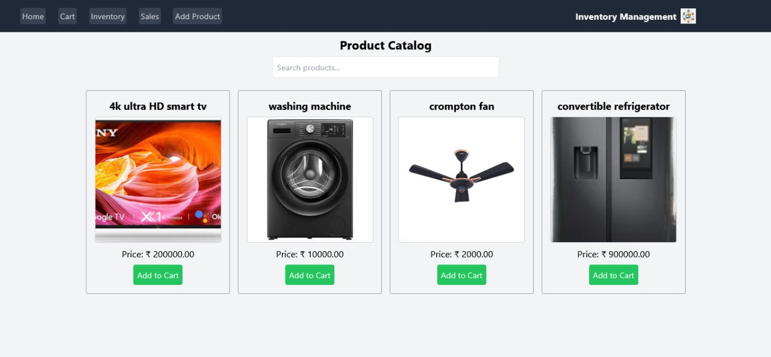

# 12.Demo:

[**https://drive.google.com/file/d/1GwGRwDkP8P39cxXXy9MC9rOz9xKvGIe2/view?usp=drive_link**](https://drive.google.com/file/d/1GwGRwDkP8P39cxXXy9MC9rOz9xKvGIe2/view?usp=drive_link)